**Report on Subsoil Investigation of Proposed Property Development At Aboke-Oko Village, Near Magboro, Obafemi/Owode Local Government Area, Ogun State.**

***Submitted to***

**MR. AYODEJI AYORINDE OLUGBADE .**

***By***

**SOIL SOL RESOURCES**

**08034471541.**

***December, 2024.***

**PROJECT RESOURCE PERSONS**

(1) Adekunle Aremu Project Coordinator/Field Geologist

(2) Musa Ojeleye Engineering Consultant

(3) Salami A.G. Senior Technologists

(4) Adam Jimoh Equipment operator

TABLE OF CONTENTS

PAGE

COVER PAGE 1

PROJECT RESOURCE PERSONS 2

TABLE OF CONTENTS 3

LIST OF FIGURES 4

LIST OF TABLES 4

LIST OF PLATES 4

LIST OF APPENDICES 4

1.0 INTRODUCTION 5

2.0 SCOPE OF INVESTIGATION 6

2.1: Site Work and Methodology 6

2.2: Laboratory Testing 7

3.0 SITE CONDITIONS 8

3.1: Site Description 8

3.2: General Geology 8

3.3: Subsoil Conditions 8

3.4: Groundwater Conditions 9

4.0 DISCUSSION OF LABORATORY RESULTS 10

4.1: Soil Grading Patterns 10

4.2: Plasticity 10

4.3: Shear Strength 10

4.4: Oedometer Consolidation 10

4.5: Chemical Analysis 10

5.0 FOUNDATION DISCUSSION & RECOMMENDATION 11

5.1: Structural Details 11

5.2: Foundation Recommendations 11

6.0 GENERAL COMMENTS AND CONCLUDING

REMARKS 13

LIST OF FIGURES

Figure 1: Base Map Showing the Test Points 7

LIST OF TABLES

Table 3.1: Summary of Subsoil Encountered 9

Table 5.1. **Structural detail** with its corresponding settlement value 11

Table 5.2. Estimated Safe Working Loads for Bored Piles 12

LIST OF PLATES

Plate 1: Dutch Cone Penetrometer Test at CPT 1 15

Plate 2: Drilling of Borehole at BH 1 15

LIST OF APPENDICES

APPENDIX A: PHOTOGRAPHS 14

APPENDIX B: SHELL AND AUGER BORING AND DUTCH CONE

PENETROMETER PROCEDURES 16

APPENDIX C: BOREHOLE LOGS 20

APPENDIX D: PENETROMETER TESTS 22

APPENDIX E: SUMMARY OF LABORATORY TESTS 24

APPENDIX F: PARTICLE SIZE GRAPHS 27

APPENDIX G: TRIAXIAL TEST GRAPHS 30

APPENDIX I: CONSOLIDATION TEST GRAPHS 32



Geotechnical, Hydrogeological, Geological, Geophysical Survey & Environmental Services.

38, Olusola-ade street, Saint Saviour bus stop, off Ijegun road,Ikotun, Lagos State.

Email: soil_sol@yahoo.com Tel: 08034471541,09056979976.

-------------------------------------------------------------------------------------

**05/12/24**

**Mr. Ayodeji Ayorinde Olugbade,**

***PROPOSED SUBSOIL INVESTIGATION ABOKE-OKO VILLAGE, OBAFEMI/OWODE LOCAL GOVERNMENT AREA, OGUN STATE.***

1.0 **INTRODUCTION**

With a view to developing the proposed property development Aboke-Oko Village, Obafemi/Owode Local Government Area, Ogun State, information on soil and subsoil conditions at the proposed construction site is required for the design and construction of suitable foundations for the structures. Therefore, our company was commissioned to conduct a detailed subsoil and geotechnical investigation on the site of the above named development.

The objectives of the investigation included but not limited to the following:

i. Determination of relevant geotechnical/engineering parameter of the soil

strata that overly the site, using the boring rig with Standard Penetrometer

Test (SPT) and penetrometer testing machine

ii. Evaluation, by the performance of laboratory tests, of the

physical/engineering properties of the soils which will influence our

recommendations on the foundation design and construction

iii. Investigation of the sub- surface soils and ground water conditions at the

vicinity of the proposed structure to depths, which will be significantly

influenced by the construction

v. Provision of information for the design of the site civil works

We have carried out the geotechnical investigation at the proposed development site and hereby present our findings.

2.0 **SCOPE OF INVESTIGATION**

i. Drilling of 1No. shell and Auger percussion boring to a depth of 22.5m

beneath the existing ground level.

ii. Performance of 2Nos. Cone penetrometer tests (CPT) terminating at depth of

refusal

iii. Laboratory tests on some selected soil samples from the field to determine their

engineering parameters that will influence the choice of foundation and design considerations

2.1 **Site Work and Methodology**

The site work was carried out between 8th – 9th November, 2024. The fieldwork comprised 1Nos. shell and Auger percussion boring sunk to 22.5 m depth below the existing ground level (BH1). 2 No. dutch cone penetrometer tests were carried out to between 3.00 m and 3.75 m depths below the existing ground level and were terminated when the test rods started to bend due to insufficient lateral support in anchorage soft soil deposits

Boring was executed using a shell and Auger cable percussion boring technique by means of a pilcon wayfarer Rig equipped with the in-situ standard penetration tests (SPT) accessories. During boring, samples were recovered at regular intervals of 0.75m while standard penetration tests (SPT) were carried out at 1.5m intervals in cohesionless strata. Figure 1 shows the Base map of the proposed site. Some photographs of boring and Dutch cone penetrometer tests activities are shown in Plates 1&2 of Appendix A

General notes on the shell and Auger boring method and a Dutch cone penetrometer test are contained in Appendix B of this report. The results of the boreholes are presented in Appendix C. The Dutch cone penetrometer tests were executed using the 2.5-ton capacity machine. The results are presented in Appendix D.

The depths referred to in this report are approximate and occurred below the existing ground level at each position as at the time of investigation.

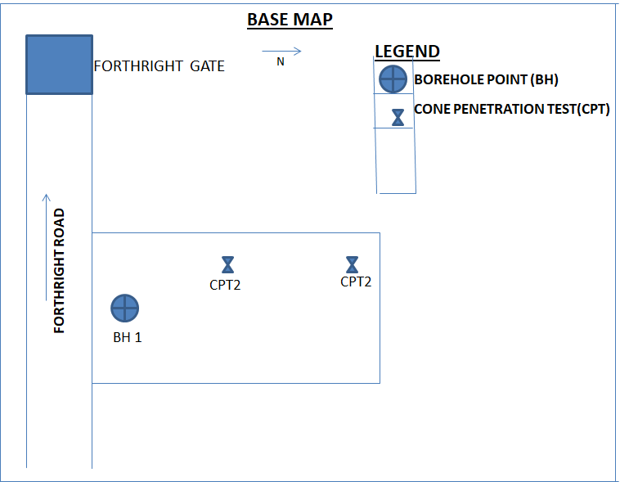

Figure 1. Base map Showing The Test Points

2.2 **Laboratory Testing**

The following laboratory tests were carried out on selected samples recovered from the boreholes.

1. 2 Nos. Atterberg limit test for classification and estimates of soil compressibility
2. 2 Nos. Natural moisture content analysis
3. 4 Nos Particle size distribution test
4. 1 Nos Oedometer consolidation test
5. 1 Nos Triaxial tests for undrained shear strength
6. 1 No. Sulphate Test
7. 1 No. Chloride Test
8. 1 No. pH (Acidity/ Alkalinity) Test

These laboratory tests are considered necessary and adequate in view of the subsoil conditions revealed, in aiding an assessment of the engineering properties of the different soil strata overlying the site. The results of these tests are summarized in Appendix E of this report.

3.0 **SITE CONDITIONS**

3.1 **Site Description**

The investigated site is at Aboke-Oko Village, Obafemi/Owode Local Government Area, Ogun State. It is a swampy landed property. At the time of investigation, the site has not been cleared of obstructions like shrubs and waterlogged. It is boredered to the west by Xtreme hotel and to the east by fallowed property. The vegetation around the proposed property is characterized by shrubs and grasses.

3.2 **General Geology**

The basement complex rocks of Nigeria are well represented in Ogun State. These rocks belong to the youngest of the three major provinces of the West African Craton recognized by Hurley and Rank (1976).

The Sedimentary rock units of Ogun State consist of the Abeokuta formation lying directly above the Basement complex. This is in turn overlain by the Ewekoro, Oshosun and Ilaro formations which are themselves overlain by the coastal plain sands (Benin Formation). The flood plains of the major rivers and streams are covered by Recent Alluvial sands. The sedimentary rocks extend from the Nigeria-Dahomey boundary in the west to Makun-Omi and Irokun in the east.

The Lithology of the Abeokuta Formation consists of sands, sometimes reddish-brown in colour. It contains intercalations of argillaceous sediments. It lies unconformably on the crystalline basement. It is Maestrichitan in age.

3.3 **Subsoil Conditions**

The stratigraphy of the sub-surface deposits, as observed from the borehole logs and penetrometer tests performed at this site, exhibited similarities in the nature of the materials occurring on this site from the beginning of the boreholes to their respective terminations as shown in Table 3.1.

The above general geology was confirmed from the boreholes and samples from the site.

**Table 3.1. Summary of Subsoil Encountered**

|  |  |  |  |  |
| --- | --- | --- | --- | --- |
| Zone | Depth Range (m) | Generalized Strata Description | NSPT (Values) | ψC (kg/cm2) |
| 1 | 0-0.23 | Denotes laterite. |  | 5 |
| 2 | 0.23 – 8.25 | Reveals soft brown organic clay to firm clay. |  | 5 |
| 3 | 8.25 – 9.00 | Represents peat within the borehole. |  | 8 -90 |
| 4 | 9.00 – 9.75 | Signifies loose grey sand | 9 |  |
| 5 | 9.75 – 22.50 | Delineates medium dense sand | 17 – 22 |  |

3.4 **Groundwater Conditions**

Groundwater was encountered at 0.20 m below the existing ground level

at the time of investigation, since this investigation was carried out during the dry season the level of the water is expected to rise appreciably above this level during wet season and the groundwater may constitute obstruction for foundation work.

4.0 **DISCUSSION OF LABORATORY RESULTS**

Detailed and critical analysis of laboratory tests from the soil samples are presented in this section of the report. The general summary of the laboratory test results are presented in Tables 4.1- 4.5 of Appendix E while the relevant graphs are shown in Appendices F to H.

4.1 **Soil Grading Patterns**

The sieve analysis carried out on the few sand samples on this site revealed that the sand is predominantly medium grained. The subsurface soil particle size distribution patterns and the corresponding gradation curves are presented in Appendix E of this report. The analysis has shown that for medium grained sand, 100% of the materials passed through the 2.00 mm sieve, 78-83% of the materials passed through the 600 micron sieve, 55-61% passed through the 425 micron sieve, 32-34% passed through the 300 micron sieve and 0-2.0% passed through the 75 micron sieve as shown in Table 4.1 of Appendix F

**4.2 Plasticity**

The liquid and plastic limits of the encountered soil deposits in Table 4.2 of Appendix E vary from 84.0-90.0% and 30.0--32.0% in the vicinity of the Borehole respectively. The plasticity index ranges from 54.0 to 58.0 %. This indicates clay of high plasticity in accordance with the casangrande plasticity chart.

**4.3 Shear Strength**

The results of the quick undrained triaxial test revealed that the cohesive component of the shear strength of the soil is 40kN/m2 with corresponding angle of internal friction of 50 in the vicinity of the borehole as shown in Table 4.3 of Appendix E. This is indicative of soft to firm clay. The undrained triaxial compression strength curves are shown in Appendix G

**4.4 Oedometer Consolidation**

The results of the one-dimensional laboratory consolidation tests and analyses on the selected undisturbed soil samples in Table 4.4 of Appendix E show that the coefficient of volume compressibility varies from about 0.208m2/MN to 0.309m2/MN with a pressure range of 0 to 400kN/m2 for soil in the vicinity of the borehole. These value obtained for the sorted samples indicate clay of medium to high compressibility. The coefficient of consolidation (Cv) obtained on the undisturbed samples varies from 2.6 to 7.3 m2/year. The initial void ratio ranges from 0.837 to 1.246. The plots of void ratio against the log of effective pressure are presented in Appendix H

**4.5 Chemical Analysis**

Analysis carried out on water sample at Boreholes 1 as shown in Table 4.5 of Appendix E reveals that sulphate content is 42.00 mg/litre while the chloride content is 400,16 mg/l. Similarly, the pH value of 5.9 indicates acidic composition. However, to ensure longevity of structures, a very rich dense mixture satisfying a minimum standard equivalent to CLASS 2 in the code of practice for foundations BS 8004: 1986 (formerly CP: 2004: 1972) should be used.

5.0 **FOUNDATION DISCUSSION & RECOMMENDATIONS**

5.1 **STRUCTURAL DETAILS**

The comments and recommendations in this section are based on this information and on careful analysis and consideration of the results of in-situ and laboratory tests results. For the purpose of this report the structural details of the proposed property with its anticipated settlement is stated below. We have assumed an average foundation loads of about 25kN/m2.for ground floor & first floor (1 storey building).

**Table 5.1. Different groups** **with their corresponding settlement values.**

|  |  |  |  |
| --- | --- | --- | --- |
| **Type of Building** | **Dimension** | **Borehole (BH)** | **Estimated Settlement (mm)** |
| One Storey (ground & upper floor) | 40.97m by 15.24m | BH1 | 64 |

5.2 **FOUNDATION RECOMMENDATIONS `**

5.2.1 **Shallow foundations**

The results of the in-situ and laboratory tests carried out revealed that the subsoil deposit on this site is made up of reddish brown laterite, soft brown organic clay to firm clay, peat, loose brown sand and medium dense brown sand from ground surface to depth of 22.50m in the vicinity of the borehole. Our careful analyses and consideration of the test results show that in its present untreated form, the subsoil structure may not be able to support the proposed structure on isolated column bases (pad footings) or reinforced concrete rigid raft foundation because the founding materials have potential for high compressibility and shear failure. In view of this revealed in situ subsoil conditions, it is necessary to improve the bearing capacity of the soil by deep soil improvement using deep seated piled foundation to transfer some load to a firmer/competent stratum beneath the highly compressible strata.

**5.3 Deep Foundation**

A form of deep foundation such as deep reinforced concrete columns can be used to transmit the column load below the depth of reddish brown laterite, soft brown organic clay to firm clay, peat and loose brown sand deposits to terminate in the **medium dense sand at depth between 13 - 16m** in the vicinity of the borehole. Such foundation should be capable of mobilizing safe working loads through the skin friction and end bearing.

The most suitable pile solution for this site is the driven precast or steel cased pile. However, driven piles do cause vibrations or disturbances and the possibility of these causing detrimental effects on nearby structures development is very high. In view of this consideration, bored piles should be adopted. A nominal overall factor of safety of 3 is applied on the ultimate bearing capacity estimated from above.

The recommended safe working load to be adopted will be much dependent on the pile type size and the depth of termination of pile, decided upon by an experienced piling contractor and structural engineer. Results of in-situ tests indicated that piles may be terminated at 13 - 16m as shown in Table 5.2.

Medium sized piles with their associated capacities estimated based on the revealed in-situ soil conditions are provided in Table 5.2 for bored and cast in-situ concrete piles.

The estimated capacities are for guidance purposes only and the piling contractor must be fully involved in the final design of piles.

**Table 5.2. Estimated Safe Working Loads for Bored Piles**

|  |  |  |  |  |
| --- | --- | --- | --- | --- |
| **Borehole(BH)** | **Pile**  **length (m)** | **Pile Diameter (mm)** | **Safe Working Load (kN)** | **Factor of Safety (F.O.S)** |
| BH1 | 13-16 | 300 | 261 | 3.0 |
| 450 | 571 |
| 600 | 794 |

Settlements of the structures and machinery set on pile with the quoted working loads are

expected to be minimal. The spacing of the piles, number per column and pattern must ensure that groups are not heavily loaded. The quoted loads are based on theoretical estimates, which are approximate. Actual working loads would be dependent on the pile method adopted by the piling contractor. The decision as regards the working load to be adopted must therefore be decided by the Structural Engineer in conjunction with the piling contractor. Also, it is advisable to carry out a pile load test prior to the commencement of the working piles to confirm the above estimated carrying capacities.

6.0 **GENERAL COMMENTS AND CONCLUDING REMARKS**

The comments and recommendations made in this report are based on the ground conditions as revealed at the positions of 1No. Borehole, 2Nos. Dutch cone penetrometer tests, as well as on the results made both in the field and in the laboratory.

There may, however, be special conditions prevailing at the site which were not disclosed by the investigation and which have therefore not been taken into account in this report.

It is strongly recommended that the design and construction of all foundations or earthworks be carried out in accordance with the engineering practice as embodied in recognized Codes of Practice such as the British Standard Institutions B.S.8004, 1986 Code of Practice for Foundation and B.S. 6031, 1981 Code of Practice for Earthwork.

Yours faithfully,

**Adekunle Aremu**

***Project Coordination/Field Geologist.***

.

**APPENDIX A**

**PHOTOGRAPHS**

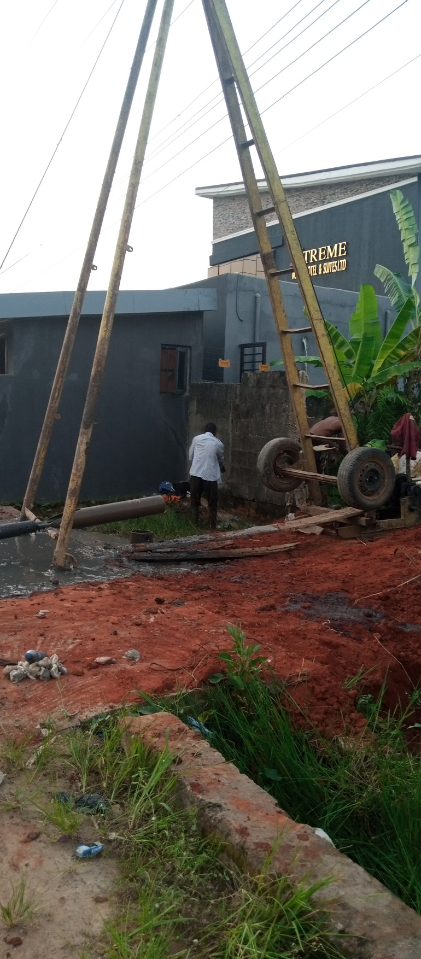

**PLATE 2.** Drilling of Borehole at BH1

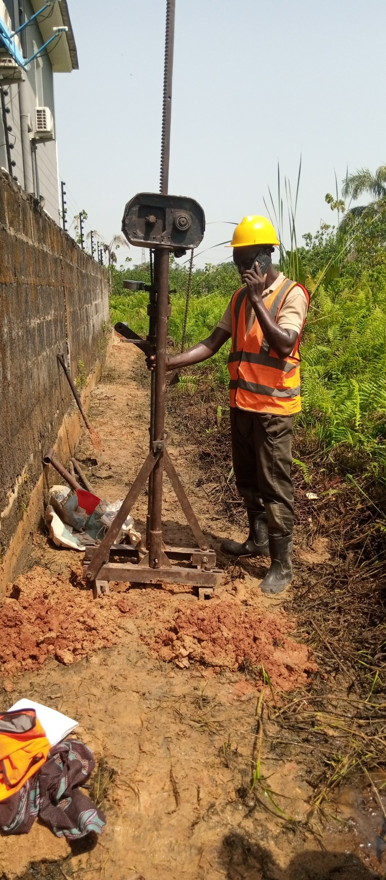

**PLATE 1.** Dutch cone penetrometer test at CPT 1

**APPENDIX B**

**SHELL AND AUGER BORING AND DUTCH CONE PENETROMETER TEST PROCEDURES**

**SHELL AND AUGER BORING PROCEDURES**

The procedures used for boring, sampling, in-situ testing and describing soils are generally in accordance with the British Standards Code of Practice for Site Investigations, B.S. 5930:1981, and with Methods of Testing Soils for Civil Engineering Purposes, B.S.1377:1975.

**Boring**

Boring in soil by the Shell and Auger or cable percussion method is based on the use of variety of tools which, with the exception of the Auger, are alternatively raised and dropped to break up and recover the soil. A Shell, which consists of a heavy, long tube with a flap valve on the bottom, is used in non-cohesive soils such as sand and gravel. An Auger (now rarely used) or a clay-cutter, which consists of an open ended, heavy long tube is used in cohesive soils. Very hard soils, boulders or other obstructions are, where feasible, broken up by chiseling and the fragments removed with the shell. The auger is worked on boring rods while the remaining tools are worked on a wire cable. Chiseling is carried out using either a heavy chisel-shaped instrument or the clay-cutter with heavy weights attached. Where the ground conditions make it necessary, the borehole is lined with steel casing which is advanced by turning or hammering. Borehole diameters vary from 250mm to 150mm with the size being selected to suit the ground conditions and to allow, where necessary, reduction to a smaller size to permit installation of casing to greater depths.

**Undistributed Samples**

Undisturbed samples of cohesive soils are taken with a 100mm (approximate) internal diameter open tube sampler fitted with a cutting shoe. The sampler is forced into the soil at the bottom of the borehole using boring rods.

After taking sample, the drive head and cutting shoe are unscrewed from the sample tube and any slurry or disturbed soil is removed from each end. The samples are then transported to the laboratory for examination and testing.

**Standard Penetration Test (SPT)**

This test is carried out in accordance with B.S. 1377:1975, Test 19. A split barrel thick-walled sampler (“split spoon”) of about 35mm internal diameter is driven 450mm into the soil by repeated blows from a trip hammer weighing 65kg and falling through 760mm. The Standard Penetration Test Resistance, or ”N” value gives an empirical measure of the soil consistencies and is also used to estimate the bearing capacity and compressibility of granular soils. The cutting shoe is often replaced with a solid cone for use in gravels. The test can also be used to provide a guide to the relative strength of weathered rock.

The following table gives the consistencies of granular and cohesive soils in terms of `N` values:-

**N-Value**

**Granular Soils** Very loose - 0-4

Loose - 4-10

Medium Dense - 10-30

Dense - 30-50

Very Dense - Over 50

**Cohesive Soils** Soft - 0-4

Firm - 4-8

Stiff to Very Stiff - 8-20

Hard - Over 30

For a slightly fuller explanation of recording “N” Values, reference should also be made to the “key to Borehole Logs” that immediately precedes the presentation of the Borehole Logs.

**THE DUTCH CONE PENETROMETER TEST**

The Dutch cone penetrometer test consists of forcing a hardened steel cone continuously into the ground and measuring its resistance to penetration. The standard cone used has an apex angle of 600 and a base area of 10 sq. cms. The penetrometer machine consists of a steel frame carrying a driving head which houses a hydraulic pressure capsule. The driving head can be raised or lowered by a manually operated winch or a motor drive hydraulic raw. The cone assembly is pushed into the ground by means of steel rods connected to the driving head. These rods are protected from friction with the soil by hollow outer rods.

The cone, driving rods and outer rods are pushed together into the ground for a distance of 250mm (200mm in the case of tests with the 2.5 tone machine). The driving pressure is then applied to the inner rods only and the cone is advanced independently of the outer rods for a distance of about 40mm at a rate of approximately 100mm/sec. The pressure required to advance the cone is transmitted through the capsule in the driving head to a guage and the penetration resistance registered on the gauge is recorded. The larger penetrometer machines are capable of recording a skin friction value of the material by advancing a friction jacket or sleeve behind the cone. The outer tube is then advanced and the whole assembly is driven a further 250mm where the operation is repeated. This process is continued to the required depth or until one of the following occurs:-

(a) the total resistance to penetration of the rods and cone reaches the capacity of the machine.

(b) the anchors start to lift out of the ground, or

(c) the rods start to bend due to insufficient lateral support in softer deposits.

Successive cone resistance and sleeve resistance readings are plotted against depth to form a resistance profile. Such profiles may be correlated with borehole data and used to provide information on the variation of strata and material strengths across a site. Where both cone and sleeve resistances are measured, the relationship between the two values can be used to indicate the soil type as well as its strength or density. If required, soil samples for identification purpose can be obtain by means of a special sampling tool which is connected to the tubes in place of the cone. The base of the sample is sealed by a piston while it is being driven into the ground. At the required sample depth, the tubes are turned and this releases the piston allowing the sampler be pushed into the soil.

**GUIDE FOR ESTIMATING SOIL TYPE (AFTER SCHMERTMAN,1969)**

**Cohesive** **Soils**

**Cone end Resistance Inferred Cu values**

**Value Soil Type After B.S. 8004:1986**

0-4 Very soft clay 20 kN/m2

0-6 Soft clay 20-40 ,,

6-10 Firm clay 40-75 ,,

10-20 Stiff clay 75-100 ,,

Above 20 Very stiff clay 100-150 ,,

To hard clay and 150.kN/m2

**Granular Soils**

**Cone end Resistance Relative Density**

**Value (kg/cm2)**

0-4 Very loose to loose

40-120 Medium dense

120-200 Dense

Above 200 Very dense

**APPENDIX C**

**BOREHOLE LOGS**

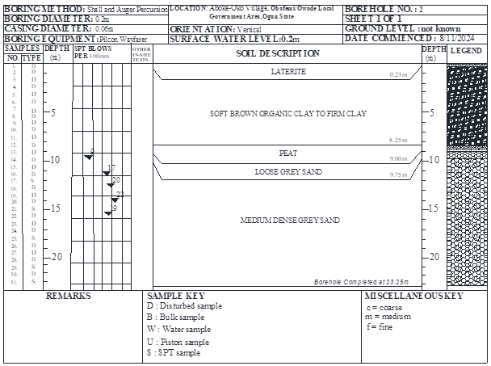

**APPENDIX D**

**PENETROMETER TESTS**

**APPENDIX E**

**SUMMARY OF LABORATORY TESTS**

**SUMMARY OF LABORATORY TESTS**

**Table 4.1. Grained Size Distribution (% PASSING)**

|  |  |  |  |  |  |  |  |  |  |
| --- | --- | --- | --- | --- | --- | --- | --- | --- | --- |
| Sample N0. | Depth(**m**) | 2.00  (**mm)** | 1.18  (**mm)** | 600 (**µm)** | 425 (**µm)** | 300 (**µm)** | 212 (**µm)** | 150 (**µm)** | 75  (**µm)** |
| **1/17** | **12.00** | **100** | **--** | **83** | **61** | **34** | **--** | **--** | **0.0** |
| **1/19** | **13.50** | **100** |  | **80** | **60** | **32** | **--** | **--** | **2.0** |
| **1/21** | **15.00** | **100** |  | **80** | **68** | **33** | **--** | **--** | **2.0** |
| **1/23** | **16.50** | **100** |  | **73** | **55** | **32** | **--** | **--** | **1.0** |

**Table4.2.Atterberg Limit Determination**

|  |  |  |  |  |  |
| --- | --- | --- | --- | --- | --- |
| Sample N0. | Depth (**m**) | NATURAL MOISTURE  CONTENT  (**Wc**%) | Liquid Limit (LL) (%) | Plastic Limit (PL) (%) | Plasticity Index (PI) (%) |
| **1/4** | **2.25** | **71.9** | **84.0** | **30.0** | **54.0** |
| **1/8** | **5.25** | **86.0** | **90.0** | **32.0** | **58.0** |

**Table 4.3. Quick Undrained Triaxial Compression Test**

|  |  |  |  |  |  |  |  |
| --- | --- | --- | --- | --- | --- | --- | --- |
| Sample N0. | Depth (**m**) | Natural Water Content (%) | Bulk Density  (Mg/m3) | Cohesion (Cu) (**k**N/m2) | Angle of Friction (Degrees) | Pressure  ϭ  (KN/m2) | COMPRESSION  STRESS  (KN/m2) |
| **1/5** | **3.00** | **54.1** | **1.686** | **40.0** | **5.0** | **50**  **100**  **200** | **100.0**  **111.0**  **128.0** |

**Table 4.4.Oedometer Consolidation Tests**

|  |  |  |  |  |
| --- | --- | --- | --- | --- |
| Sample N0. | Depth (**m**) | Pressure Range (k**N**/**m2**) | Coeff. Of Compressibility Mv;(**m2**) | Coeff. Of Consolidation Cv;(**m2**/year) |
| **1/5** | **3.00** | **0-25**  **25-50**  **50-100**  **100-200**  **200-400** | **0.208**  **0.309**  **0.285**  **0.253**  **0.224** | **7.3**  **5.6**  **4.1**  **3.3**  **2.6** |

**Table 4.5. Chemical Analysis of Water sample**

|  |  |  |  |
| --- | --- | --- | --- |
| **Samples No. / type** | **pH value at 260C** | **Chloride content (mg/litre)** | **Sulphate content (mg/litre)** |
| BH1 | 5.9 | 400.16 | 42.00 |

**APPENDIX F**

PARTICLE SIZE GRAPHS

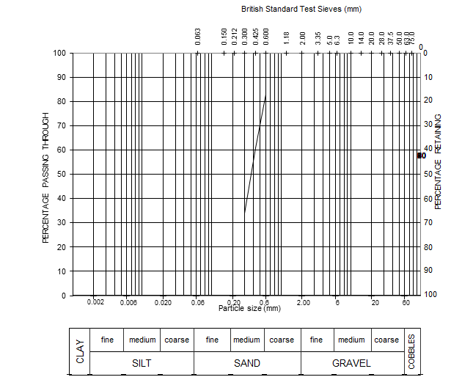

|  |  |  |  |
| --- | --- | --- | --- |
| **SAMPLE NO.** | **DEPTH(M)** | **DESCRIPTION** | **`WATER CONTENT (%)** |
| **1/17** | **12.0** | Brown sand (m) | **15.9** |

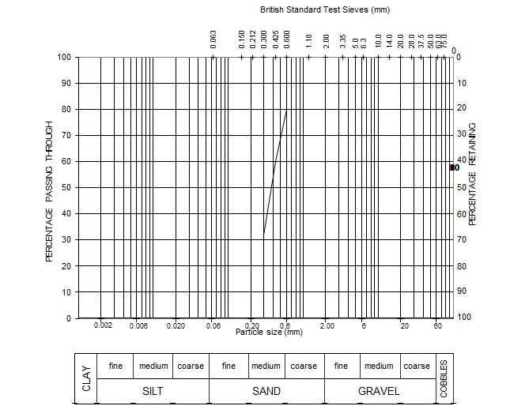

|  |  |  |  |
| --- | --- | --- | --- |
| **SAMPLE NO.** | **DEPTH(M)** | **DESCRIPTION** | **`WATER CONTENT (%)** |
| **1/19** | **13.50** | Brown sand (m) | **17.4** |



|  |  |  |  |
| --- | --- | --- | --- |
| **SAMPLE NO.** | **DEPTH(M)** | **DESCRIPTION** | **`WATER CONTENT (%)** |
| **1/21** | **15.00** | Brown sand (m) | **18.2** |

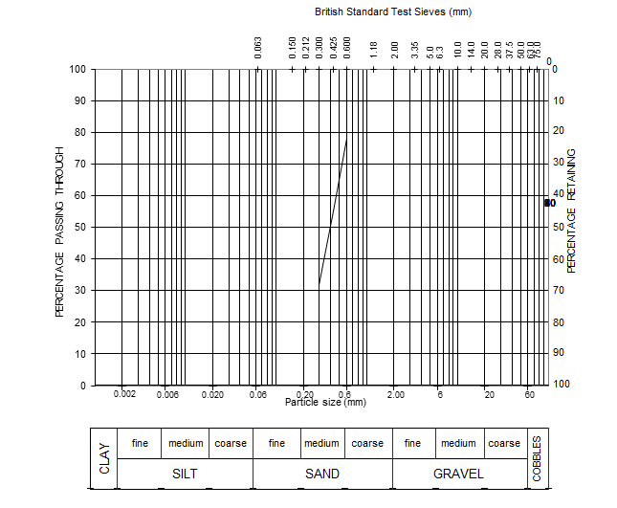

|  |  |  |  |
| --- | --- | --- | --- |
| **SAMPLE NO.** | **DEPTH(M)** | **DESCRIPTION** | **`WATER CONTENT (%)** |
| **1/23** | **16.50** | Brown Sand (m) | **19.8** |

**APPENDIX G**

TRIAXIAL TEST GRAPHS

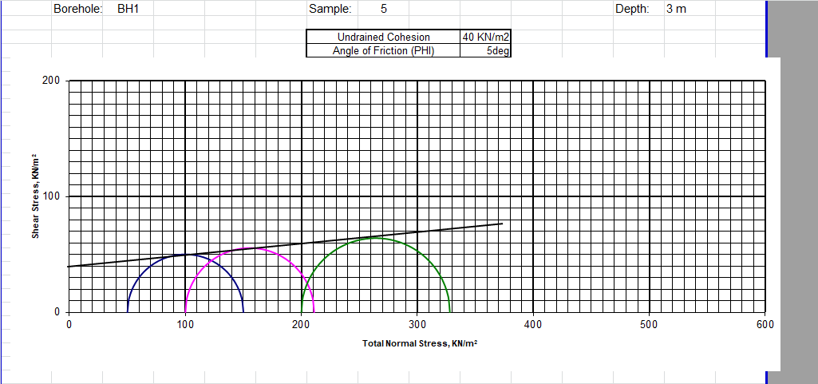

|  |  |  |  |  |  |  |  |  |  |  |  |  |  |  |  |
| --- | --- | --- | --- | --- | --- | --- | --- | --- | --- | --- | --- | --- | --- | --- | --- |
|  |  |  |  |  |  |  |  |  |  |  |  |  |  |  |  |

**APPENDIX H**

CONSOLIDATION TEST GRAPHS

